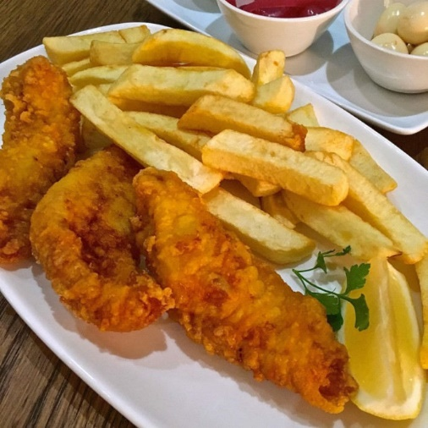
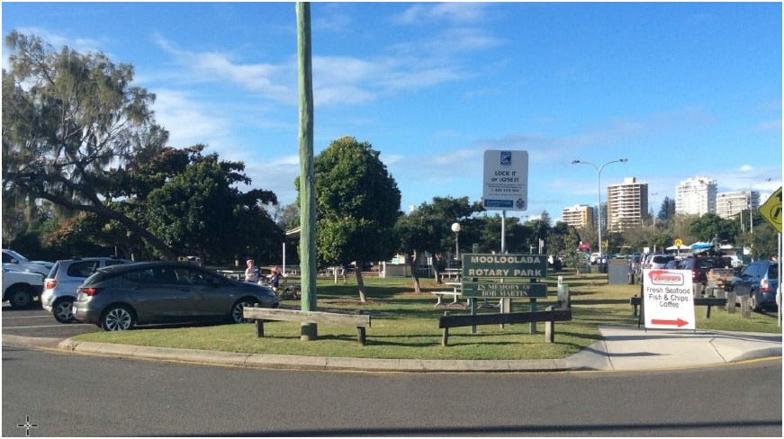
Fish and Chips on August 7th On the Spit at Mooloolaba

Meet at the picnic tables at 11:00 am at Mooloolaba Rotary Park, Parkyn Parade to enjoy your thermos of coffee/tea while catching up with register friends.
At about 12:00 we will wander across the road to buy fish and chips or a burger for lunch.
Plenty of parking opportunities.
Please Rsvp by Monday 5th August to herbert.casino@gmail.com

