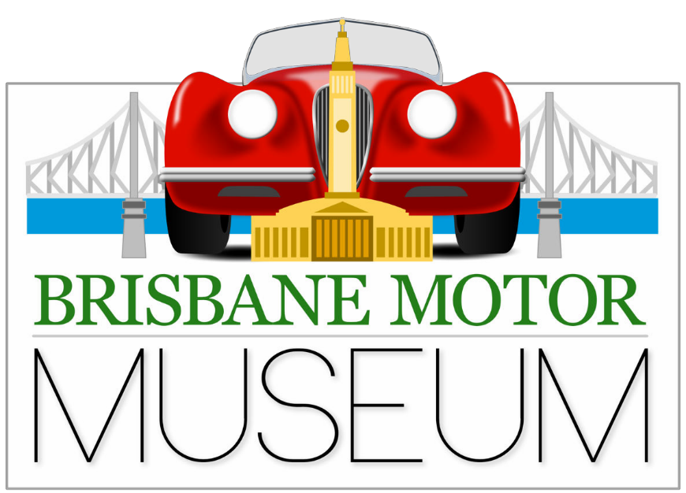
Visit to Brisbane Motor Museum & Ladies’ Morning Tea
11th*October 2023 @ 10am
959 Nudgee Rd,Banyo

We know the men never get sick of looking at cars and most of the ladies have seen as many as they want so we are combining the two events.
There is an interesting selection of cars, JDCQ memorabilia AND a very nice coffee shop with comfy chairs.

Our special tour guide will be owner and SC member, Col Galley.

To show our appreciation to our very supportive ladies, JDCQ is contributing $10
towards each ladies’ morning tea.
RSVP: Wendy 0498203257 or goodwillpark2@gmail.com by 8th October.
Admission: $20pp

