JDCQSC 2023 Away Trip- Mt Tamborine

Tuesday - Friday 5th- 8th September 2023 (four days, three nights)
This trip is pay as you go apart from visit to Summerland Camels and Coffee Plantation.
Highlights
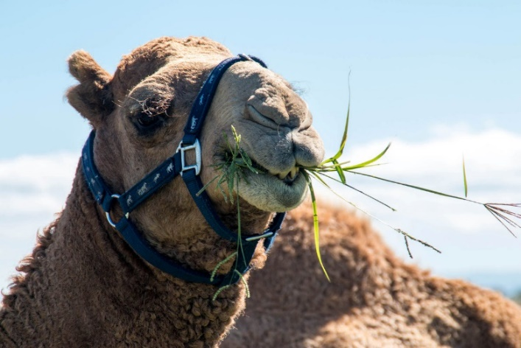
Farm tour, product tasting and lunch at Summerland Camels (approx. $20pp + lunch).
The Camel shanks are large enough to serve four.
Glow Worm caves ($17-20 pp) Gold Coast Motor Museum ($15) Rainforest Skywalk, Botanical Gardens, Winery Tours, Shopping, Coffee Plantation visit
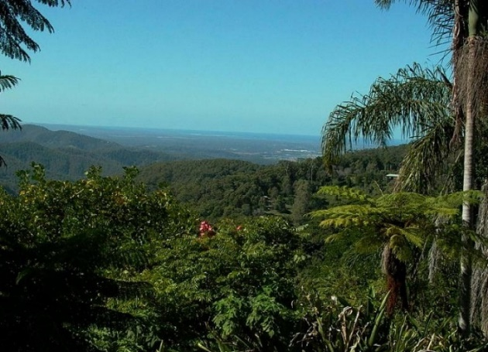
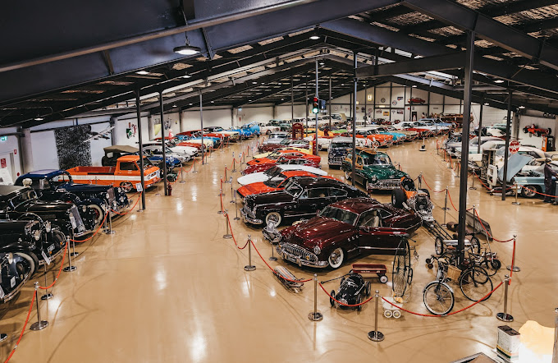

We will be staying at Mt Tamborine Motel at $150 per night.

For detailed itinerary and booking information please contact Wendy Gross 0498 203 257 goodwillpark2@gmail.com )

