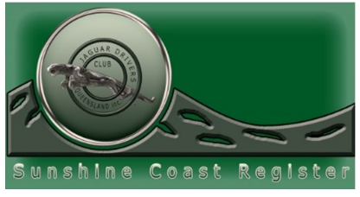

***Run to Hell Town Hotrods 16th October 2024***

***Trip Leaders : Rick and Lousie Blundell.***

***Meeting Place: Pioneer Park, Landsborough at 10.15am for BYO Morning Tea. Departure at 10.45am***

***The run duration to “Hell Town Hotrods” via the route I have chosen  is !hr 30 mins so we need to leave at 10.45/ 11.00am  latest.***

***The drive will go via Mooloolah Valley, Palmwoods, Kiel Mountain, Diddillbah, Bli Bli, Yandina, Eumundi, Cooroy, Pomona, Cooran and Traveston to “Hell Town Hotrods” at Kybong for lunch at 12.30/12.45 pm.***

***If you have not been there before there is lots to see with old cars and bikes. The theme is “Rock and Roll”.***

[***https://www.streetmachine.com.au/features/inside-hell-town-hotrods***](https://www.streetmachine.com.au/features/inside-hell-town-hotrods)

RSVP: by 10th Oct to [twobees@tpg.com.au](mailto:twobees@tpg.com.au)

